Asia-Japan-Mirrors-Gunma

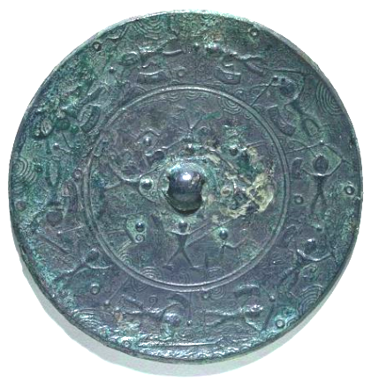

Bronze mirror from Gunma Prefecture (Tokyo National Museum)

http://heritageofjapan.files.wordpress.com/2008/07/m1-gunma-prefecture-bronze-mirror-tokyo-national-museum.jpg?w=500&h=478